Professor Jesse Bird & Bird College
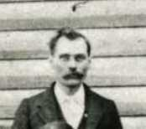

Jesse Bird (picture extracted from Hindsville Academy photograph – Madison County Historical Society)
Perhaps the most remembered educator in early Madison County history was Professor Jesse Bird. Much of what is known about the life of Prof. Bird comes from the early writings of William Herschel Hughes, a former student of Bird and former teacher in Madison County and from U. S. census records.
Jesse Bird was born in June, 1850 in Kentucky to Jesse and L. Bird, the youngest of five children of this Methodist minister and his wife. In a 1933 news article, Hughes states that Bird was educated at the University of Virginia and had engaged in newspaper work in Richmond and Cincinnati and later practiced law in Lexington, Kentucky. In the 1870 U.S. Census of Buchanan County, Missouri, Jesse Bird is living with one Benjamin Bird, perhaps an uncle or brother, and states his vocation as “Lawyer”.
In a 1962 article for the Arkansas Democrat, Hughes states that he is a graduate of Transylvania College (Lexington, KY) rather than the University of Virginia which he made reference to in his 1933 article.

. . . Professor Bird was a graduate of Transylvania College, and except for the interlude of the Civil War, had taught in Kentucky and Tennessee until he moved to Arkansas in 1885. He bought a small farm where he grew fruits and flowers. He was a great teacher and encouraged us to read the impressive literature of the world. He often forgot the routine of class pressure, and talked about the historic campaigns and magnetic leaders he had known. As if by magic, the years fell from him and together, we lived those epochal events of the fateful '60's. . . .
In 1880, he is living in Charleston, Mississippi County, Missouri, is single and is practicing law. Professor Bird arrives in Madison County about 1885 and begins to teach school in the Whitener School District near Hindsville. The following year, he founded the Hindsville Academy.

“When he came to Madison County he put city life behind him forever and for 40 years he was content with his career as a country school teacher. He found an inadequate makeshift school system that offered the most meager elementary training three months each year. Occasionally there were a few months of subscription school, but the teachers were poorly prepared to train others.
Schools were taught in rude log huts unfit for winter use. Each district adopted its own texts and planned its course of study. Not a school was graded. The ambitious boy or girl found no place in the county for the equivalent of a high school education.
Bird founded the old Hindsville Academy and brought to the mountain youth the classic traditions of the cultured East. He selected a faculty of college-trained teachers, and made the village the center of learning for the county. Strong courses were offered in mathematics, English, history and teacher training. The fame of the academy spread and many came from other counties.”
Hindsville Academy opened the doors to schooling to every deserving student. If the applicant was unable to pay the small tuition fee, he was enrolled anyway and a place found where work paid the board.

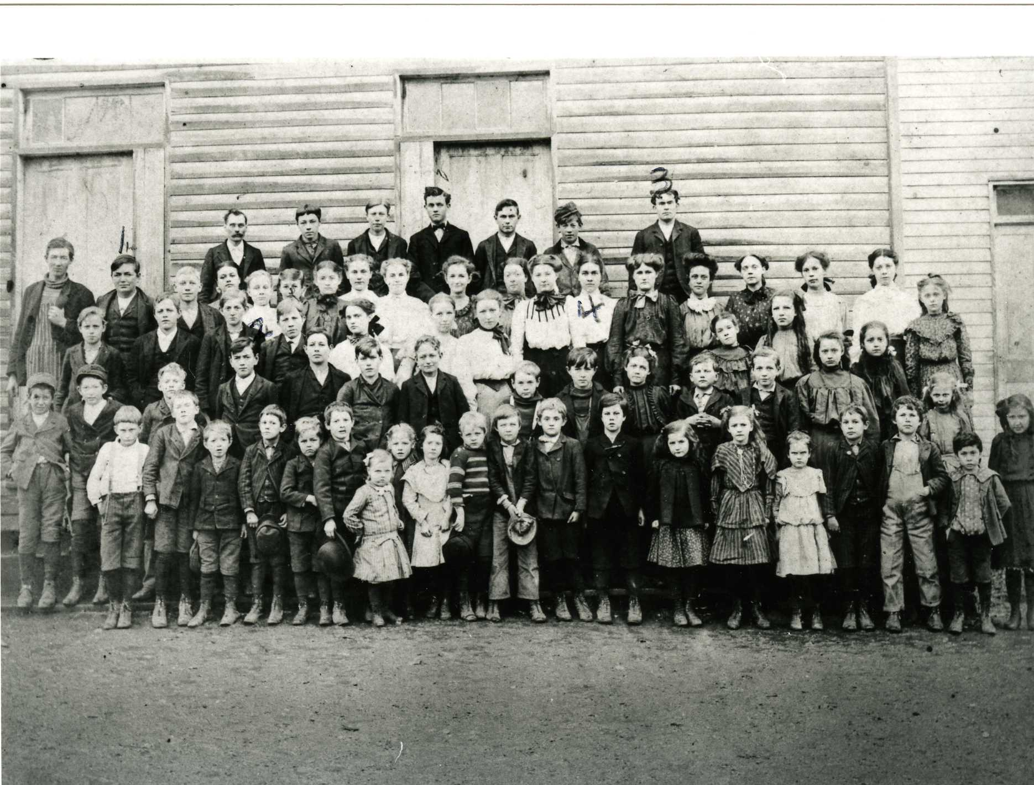

Hindsville Academy – Courtesy of the Madison County Genealogical & Historical Society
During the next three years, Professor Bird would teach and run the Hindsville Academy. In 1890, he moved to Huntsville where he became the principal of Huntsville High School.

September 11 1890 - Huntsville Democrat

Huntsville High School – The Huntsville High School will open, Fall term on Wednesday September 10, 1890 and continue thirty-six weeks. Board can be obtained at $8 and $10 per month. Tuition is $1.50 and $2.50 per month according to grade.
Jesse Bird, Principal

An ad in the same issue of the newspaper also announces the opening of Hindsville Academy for the new school year with J. W. Southerland as principal.
For the next two years, Bird would serve as principal of the Huntsville High School. However, during this period, he incurred the displeasure of the board of directors and his contract was not renewed. As a result of his non-renewal, Bird College was founded.
In a December 1977 article for The Madison County Record, former student and educator Newt Reynolds wrote:

“There is an interesting story concerning the existence of this college. [Bird College] Prof. Bird, while teaching Huntsville’s regular school, incurred the displeasure of one or some of the directors who refused to employ him for another school year. It seems that most of the patrons of the district were disappointed because of the dismissal of Mr. Bird. One of these upset patrons was the late W. A. (Bill) Wheeler, who after conferring with a number of the dissatisfied patrons, then asked Professor Bird not to leave town to find another school for he intended to build a house for him in which to hold school for the next year, and that he and many of the patrons would send their children to him and pay tuition for that year’s schooling. So, a house was soon erected and most of the children attended school there that year. This house hereafter was referred to as Bird’s College.”
The Bird College building was erected on what is now known as Governor’s Hill, about ¼ mile south of Lowe’s Spring. (Note: Lowe’s Spring is located just off Lakeview Place and feeds the small lake in that neighborhood)

An advertisement in the Madison County Record in 1892 announced the opening of the fall term of the school:

BIRD'S HIGH SCHOOL
Huntsville, Ark.
Fall Term Will Open
Monday Sept. 6th, 1892

And continue forty weeks. Fall term 16 weeks. Winter and Spring terms 12 weeks each. Tuition $2.00 and $4.00 per month, according to grade--payable each term in advance. Incidental fee $2.00 per year. Deduction made only in case of protracted sickness. Board can be obtained at $8 and $10 per month. The only school in Madison County furnishing instruction in a high school course.
Jesse Bird,
Principal

According to Reynolds, the following year a new director was elected and Prof. Bird was re-hired as principal of the Huntsville High School. It appears that school may have been held in both the Bird College building and the Huntsville school building on College Street. Mr. Reynolds stated that he had attended school there when Mr. Abraham Easterling was teaching at the school. Whether this was Bird College or Huntsville High School is uncertain.

The following picture is thought to be the Bird College building, taken in 1896. The photo is only identified as Huntsville school, 1896, Stella Brodie, teacher. The building’s architectural features do not match the College Street school or other known buildings in Huntsville during this period.
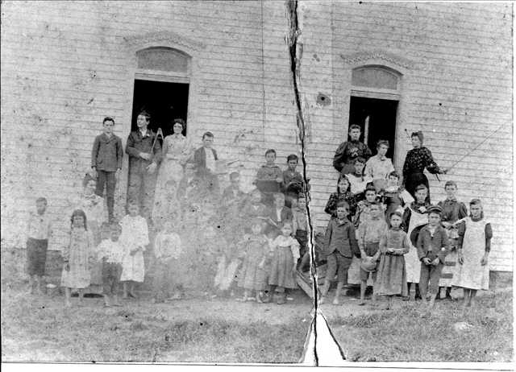

Thought to be Bird College, 1896 – (Madison County Genealogical and Historical Society)

Evidence that Professor Bird's college was well thought of in the community is found in the biographies of many of the prominent citizens of early Huntsville as many of them sent their children to him for their education. Although Bird College would operate for only about 8-10 years, many people today still remember the contributions made by Professor Bird to the educational development of the area.
W. H. Hughes makes reference to the founding of Bird College and his personal admiration for Mr. Bird in his 1933 magazine article:

“A private school building was erected and equipped for his use at Huntsville and he established a county normal school. For years there were few teachers in the county who had not been partly trained at this school. Students with college ambition found the preparatory course ample. He was a born teacher, sympathetic, patient, and painstaking. He was counselor and friend.”
During the next four years (1892 – 1896), Prof. Bird’s schools would be the center of education in the Huntsville area. The following four years of Bird’s life are somewhat of a conundrum and are particularly difficult to follow as he appears to leave Madison County for periods of time, get married, and shows up in areas that former students seem to know very little about.
While all seems to be going well in Huntsville, Professor Bird moves, at least temporarily, to Heber Springs in Cleburne County. On May 28, 1896, the following appears in The Jacksonian, the Heber Springs newspaper:

“Prof. Bird, from near Fayetteville, has charge of our State Normal. He is a thorough instructor and we believe will give the best of satisfaction.”
It appears that Bird was not teaching a regular term of High School as he did in Madison County, but was conducting teacher education courses (the Normal) only. The Normal usually began as soon as the public school ended its spring term and normally lasted about six weeks. Traveling from Madison County to Cleburne County to conduct a six week normal contributes to the mystery of this period and seems to indicate a need for ready cash.
On June 4, 1896, the following comments were made once again in the Local Notes of The Jacksonian:
“The Normal is growing in popularity every day.”
“No mistake was made when Prof. Bird was chosen to conduct the Normal at this place.”

Two weeks later, the newspaper reported:

“The State Normal closes this week. Prof. Jesse Bird is an able instructor and has done some of the best work during his stay with us.”
The preceding indicates that Bird planned to be in the Heber Springs area for only a short time.
Months later, in the fall of 1896, he would return to Hindsville Academy to open its 9th and final year. The following ad appears in the Madison County Democrat on September 16, 1896:

Hindsville Academy
9th Year
Hindsville Academy will open Fall Term
Monday, Sep. 14th, 1896
And continue forty weeks. Fall term 16 weeks.
Winter and Spring Terms 12 weeks each.
Tuition $2.00 and $4.00 per month, according to grade. Payable each term in advance.
Incidental fee $2 per year. Deduction made only
In case of protracted sickness. Board can be obtained
At $8 and $10 per month.
The only school in Madison county furnishing
instruction in a High School course.

Jesse Bird,
Principal

This ad also appears on April 28, 1897. Even though the Fall term was over and no mention of starting dates of the winter and spring terms are mentioned, it was common to run the same ad without changes off and on during the school year. This type of “outdated” ad appears many times in Madison County newspapers during this period.
In this same issue, the editor mentions in his “Locals” column that “County Examiner Jesse Bird spent Saturday and Sunday in the city.” The following advertisement is displayed on the previous page:

Notice to Teachers
Office of County examiner,
Hindsville, Ark
April 3rd, 1897
The County Normal will be held at Huntsville, commencing Thursday, the 3rd day of June, 1897. Board may be had at $1.50 and $2.00 per week.
The law says “All persons holding County Certificates to teach in the public schools of Arkansas
are required to attend said Normal, the full time, under penalty of forfeiture of license, which may be restored only by re-examination; provided that the instructor may, for good and sufficient reasons, by and with the consent of the County Examiner, excuse any teacher from such attendance.” Public examinations July 1st and 2nd, 1897.

Jesse Bird,
County Examiner

Professor Bird was appointed as County Examiner in Madison County in 1896. In 1897, he would also marry for the first time to Sallie Southerland who had been married previously and had three children, Luna Southerland, age 7, Beulah Southerland, age 5, and Clara age 3. Future writing would indicate that he experienced family and financial problems and for whatever reason, Bird vacated the office of county supervisor shortly after his appointment, probably in late 1897. Whether the educational climate of Madison County was not to his liking or his family was not happy in the area, he began to search for other venues in which to practice. A front page news story in the Fort Gibson Post, Fort Gibson, Oklahoma on August 25, 1898 reported the following:

A BIG COLLEGE ASSURED

One to be Established at Fort Gibson at Once. The Tide of Good Fortune Comin Our Way at Last—Other Good Things Will Follow,

Fort Gibson is to have, among other important enterprises and institutions, a college! There is practically no doubt about it. The preliminary details are already settled and the institution is assured.

Prof. Jesse Bird, an old and experienced educator of Huntsville, Ark., is the promoter of this important acquisition to our growing little city. He has been in town several days this week looking over the field and has decided that Fort Gibson is the coming city of Indian Territory, and consequently the host point at which to begin the foundation of a great educational institution.

Prof. Bird has been president of the Hindsville (Ark.) Academy and the Huntsville High School for nearly fifteen years. Several years ago when his town gave promise of becoming a large city he established Hindsville Academy and built a fine college structure. But, as is often the case, a railroad missed his town several miles and killed it. Last winter, however, Prof. Bird disposed of his college property to advantage and began looking, out for a more promising location for a large educational institution. He went through Missouri, but found the field all occupied. By mere chance he heard of Fort Gibson, down here in the little known Indian Territory—a town destined to grow into the metropolis of the great Southwest. He came down here to investigate. He found a magnificent location—unoccupied. He could see a grand future for our town, great promise in our natural advantages and resource, and he saw superb health in the crystal waters of the beautiful Grand river. An ideal location for the up-building a great college and a great city.

Well, to make a long story short, Prof. Bird will establish his school at Fort Gibson—temporarily perhaps until a suitable structure can be built. The name of the college and further information regarding the establishment of this important institution will be given in our next.

But the college is a certainty.

Prof. Bird departed yesterday and will return in a few days and take up his permanent residence here.
What happened to Bird’s proposed Ft. Gibson school is not known. It does appear that he returned to Heber Springs as he and his family are listed in the 1900 U. S. Census for Cleburne County. The census further indicates that in March, 1900, Sallie gave birth to the first of two sons, Harold and three years later, Ray. There are no records of Prof. Bird having taught in Madison County from 1898 – 1900.
About 1901, he and his family return to Madison County where records indicate that he taught both at Huntsville and the Hindsville public school. In the years that follow, county records indicate that he taught at the following schools:

1901 – Huntsville & Hindsville
1902 – Hindsville & Wesley
1903 – Clifty
1904 – Huntsville
1905 – Huntsville
1906 – Huntsville
1907 – Huntsville
1908 – St. Paul
1909 – St. Paul
1910 – St. Paul
1911 – St. Paul
1912 – Pettigrew
1913 – Huntsville
1914 – Dutton
1915 – Dutton
1917 – Cass in Franklin Co.
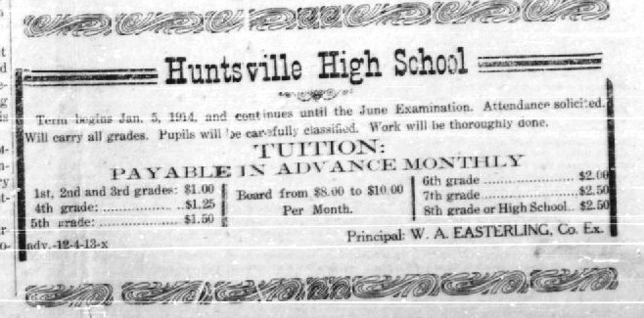
In the winter of 1913, the Huntsville Academy building on College Street was destroyed by fire. It has always been assumed that classes were moved to the Bird College building following the fire as it was reported that the summer Teacher’s Institute was held at Bird College. An interesting set of advertisements appeared in the February 1914 issues of the Huntsville Republican. Abraham Easterling ran an ad in all four weekly February issues announcing the winter term of Huntsville High School.

In the same issues, Prof. Bird also announced his term of school which was to be held in the Bird College Building.

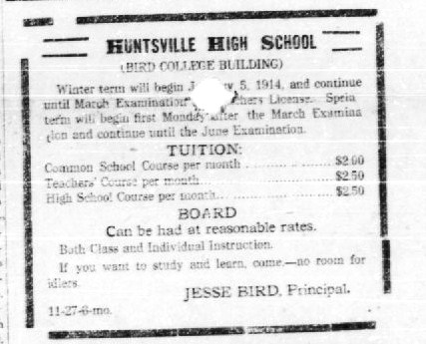

It is not known if two schools were conducted in Huntsville that winter, the public school and Bird’s private school. Furthermore, where was the public school holding classes? It must be assumed that the public school made use of local churches or the Masonic building to conduct their classed until a new school could be erected. Mr. Easterling was listed as a member of the Huntsville faculty in 1914 while Prof. Bird was listed as being employed by the Dutton school district according to county records. It is assumed that Bird conducted a spring term through June at his college building and then accepted a position at Dutton in the fall.
In the short years that followed, Prof. Bird began to lose his eyesight and by 1920, he was nearly totally blind. About this time, his wife and family once again left him and he was not only blind, but alone, and destitute. In April, 1923, while visiting in Huntsville, he became very ill and was taken to the Fayetteville hospital. A fund was started by his friends in the area to help pay for his care while there. Many doubted that he could recover from his illness. According to the local newspaper, if his health improved sufficiently, he would travel to Kansas City to stay with his family “but it is very doubtful if he lives many days.”
Professor Bird died on December 26, 1923, at the county farm, and was buried as a pauper in the Huntsville Cemetery in an unmarked grave near the row of tall cedars which separates the old and new sections of the cemetery. An article published the following day in the Madison County Record reported his death:

PROF. JESSE BIRD DEAD

Professor Jesse Bird, well known school teacher, died yesterday at the county home where he had been about a week, and his remains were buried this afternoon in the Huntsville Cemetery, the funeral service being conducted by Rev. J. M. Bandeen of Hindsville.

For a long time Prof. Bird had been in failing health and during the past three years, because of almost total blindness which compelled him to quit the school room, he had been in charge on the charity of his friends. Most of the time he resided at Saint Paul but during the past year he spent several weeks at Huntsville, coming here the last time on October 30, and was cared for at the City Hospital until the 19th when his physical condition grew so serious that it became necessary that he be taken to the county home where he could have constant attention which could not be provided for him at a hotel or private boarding house. The Record is unable to learn anything about Prof. Bird's life prior to his residence in this county, which began about 35 years ago. It is understood, however, that he was a native of Kentucky and it is known that he came here from Missouri. His age was about 74 years. He was very highly educated and was recognized as one of the ablest instructors in the state. He was qualified to have filled chairs in the leading universities but seemed to prefer work in the public schools. His first school in the county was at Whitener and after that he taught at various places in the county, including Huntsville. The deceased is survived by his wife and one son, but according to his statements, they had both forsaken him. The son is serving an enlistment in the navy, and it seems, he could have made some allotment toward his father's support if he had wanted to. Mrs. Bird had been residing in Kansas City for quite awhile but recently she came to Elkins and, in justice to her, we will say that it is reported that she came here with the intention of taking care of Prof. Bird, and it is a fact that he went from St. Paul to this wife's home in Elkins but he did not remain long. He came from there to Huntsville on October 30, as stated above, and made known that he was still an object of charity. He refused to talk of why he did not stay with his wife other than to say there was no possibility whatever of a recounciliation (sic) between them. There is usually two sides to every marital infelicities, and we shall not say which side was most wrong in this unhappy home. We regret his sad ending, for as a pupil of Prof. Bird we esteemed him for his worth as a teacher and his favor as a friend.

The respect that many former students had for Prof. Bird is evident in the many reminiscences, letters, and poems written about him.
Marguerite Gilstrap, who lived in the Washington, D.C. area in 1990 and knew Professor Bird gave insight into the feelings and respect many people held for Professor Bird:

Perhaps the best way to introduce Professor Bird to you is to tell you. . . . I was reminded of him as I read Frederick Crews review of "Mark Twain and Science: Adventures of the Mind" by Sherwood Cummings in the current issue of The New York Review of Books. Cummings shows Twain was responding creatively to a general crisis that involved much more than his own feelings. He was exploring the metaphysical void that had been opened by . . . Darwin's theory of evolution and other books. . . .

In the spring of 1920, after school was out in Saint Paul, my father, who admired Professor Bird and knew his desperate needs--he was nearly blind, had no income, his family left, he lived alone--hired him to tutor me in algebra. He came to our house and we did some algebra problems. One day he brought his copy of "Tom Sawyer." My brother Dick and I read it and were of course, enchanted. His love of knowledge and his need to share it were the driving forces in his life. . .

He was the principal of the school in 1910. In appearance, he was a sparse man, about 5 feet 10, clean shaven, a pink but not ruddy complexion, with blue eyes, greying hair. In my memories, he always wears a cap. In the summer, we would see Professor Bird in his garden, with a hoe. . . . A man who had dedicated his entire life to the betterment of his fellowman and now, was penniless and destitute with no family. . . .
From William H. Hughes:

For years there were few teachers in the county who had not been partly trained at this school. Students with college ambition found the preparatory course ample. He was a born teacher, sympathetic, patient, and painstaking. He was counselor and friend.
While teaching his classes he became blind. He was taken to the county farm, penniless and desperately ill. In a dingy room in the shadow of the old academy where he had sacrificed so many years for the youth of his adopted state, the worn teacher lay down to die.

Madison County Record, 31 January 1924:

Starts Fund for Prof. Bird Monument

Mena, Arkansas, January 26, 1924: Editor Madison County Record: It was indeed with a pang of sadness that I read of the death of my old friend and school master, Prof. Jesse Bird, and of the sad manner in which his life closed. I think I knew Prof. Bird as only a few of his students knew him. Faults he had, to be sure, but who has not? There never was but one perfect man on earth and he was crucified. We live in the deeds which we accomplish and not in dollars and cents which we accumulate and leave behind. Many of the world’s greatest men have died in abject poverty, in bare attic chambers or in almshouses, and yet their gems of literature, art and science decorate the pages of history of all time to come.
Next to my mother, I feel that I owe my deepest debt of gratitude to Mr. Bird for the shaping and molding of character and preparing me to meet life’s problems. Generous to a fault, knowing not and neither caring for the value of money, his generous deeds live in the hearts of
those who were recipients of his generosity. Although qualified to fill any station in life he chose to serve among the meek and lowly, with the result that many young men and women were enabled to get broader views of life and its responsibilities.

The following poem, by Mrs. Lovejoy, might truly have been written about Prof. Bird.

O, my people; journeying onward,
You of Christ’s great brotherhood
Heed the lessons which He gives you
Written in his blessed word,
Strong and clear and full of meaning
Comb, If you would follow me
Down among the poor and lowly;
Here your Christian work must be.
This the path which you must follow,
This the way the Saviour trod;
And he teaches this will lead you
Into peace and up to God.
‘Tis in deed, we serve the Master,
Words are idle, empty prayer;
All our Christian life a pretense,
If the deeds are wanting there.
If you will but heed this lesson,
Which the blessed Savor gave,
Going out into the by-ways,
Seeking those he came to save.
Telling them in wondrous story,
With an earnest heart of Love,
Yours will be a glorious harvest
Gathered for the fold above.

Gone is one who devoted his life to the elevation and betterment of mankind. We shall not see his emaciated form – not even a semblance of his former self – blindly feeling his way along the streets, accepting charity whenever it might be meted out.
Former schoolmates and pupils of Prof. Bird, we have a duty to perform, one which, I am sure, you will all join in cheerfully, viz: That of erecting a suitable monument to his memory, with the simple inscription there on “Prof. Bird” or something else more suitable. The enclosed check of five dollars is for the purpose of starting such a fund. Now, Mr. Editor, will you please pass the hat and keep tabs and oblige.

Very truly yours, W. C. Skaggs

One of the great stains on Madison County is that this man who had done so much for so many people, died on the poor farm, penniless and uncared for, without someone to comfort him. - Newt Reynolds 1977.

U.S. Census, 1860, Clinton County, Missouri.
The Arkansas Gazette Magazine, Feb. 19, 1933, p. 13.
1880 U.S. Census, Mississippi County, MO.
Op. Cit. The Arkansas Gazette Magazine.
Abstracts from The Jacksonian Newspaper: Published in Heber Springs, Arkansas, 1894 – 1896. Arkansas Research, Inc., Conway, Arkansas. Copyright 2005, p. 169.
The Madison County Democrat, Huntsville, Arkansas, September 16, 1896, page 1, Column 1.
The Madison County Democrat, Huntsville, Arkansas, April 28, 1897, Col. 1, page 1.
Records of the Madison County Court, Huntsville, Arkansas, Vols. A-Z, 1878-1948, 240.
U.S. Census, 1900, Cleburne County, Arkansas.

